(HONORS) GEOMETRY NAME: _____________________
Unit 8 Lesson 4 – Volume of Pyramids and Cylinders BLK: _____ DATE: ___________

Volume:

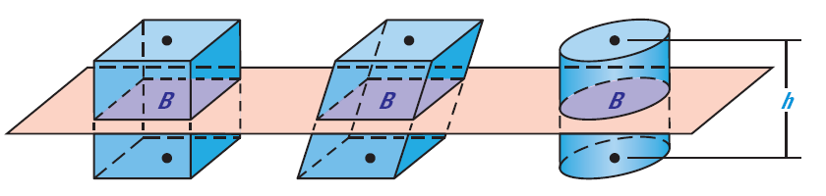
Cavalieri’s Principle

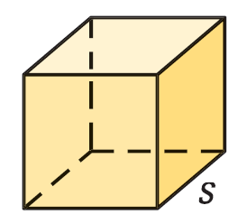
Volume of a cube:

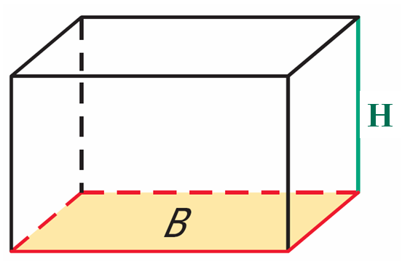
Volume of a Prism:

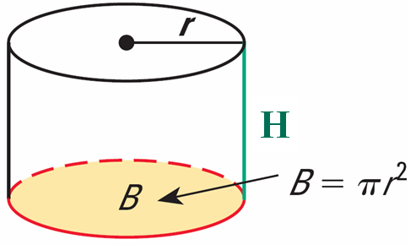
Volume of a Cylinder:

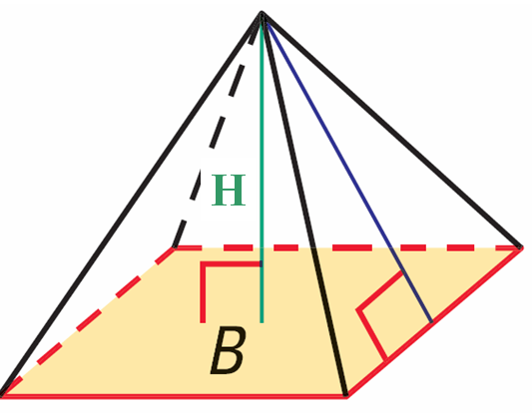
Volume of a Pyramid:

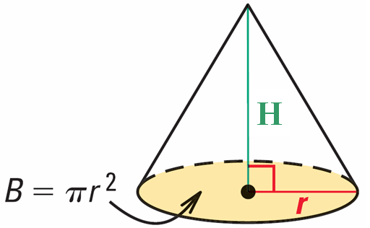
Volume of a Cone:

1. Find the volume of the prism.
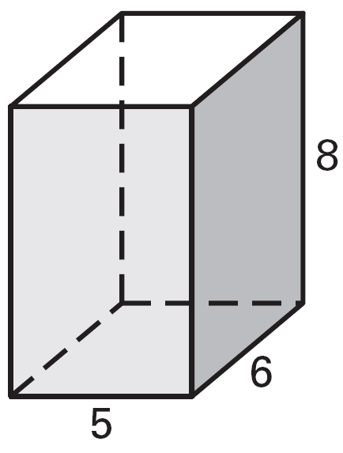

V = _____________

2. Find the volume of the prism.
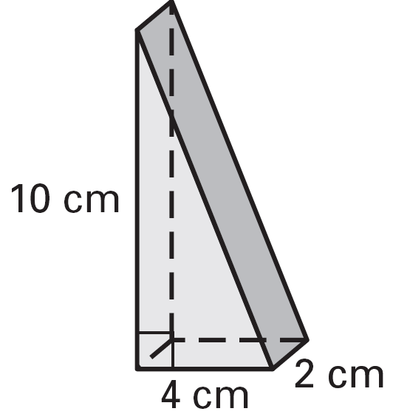

V = _____________

3. Find the volume of the cylinder.
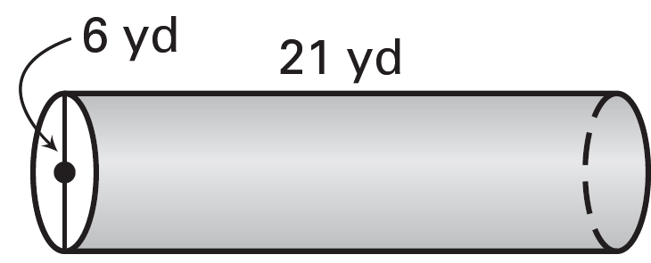

V = _____________

4. Find the volume of the pyramid.
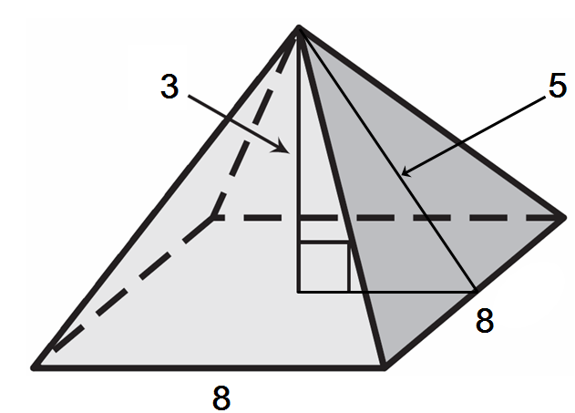

V = _____________

5. Find the volume of the pyramid.
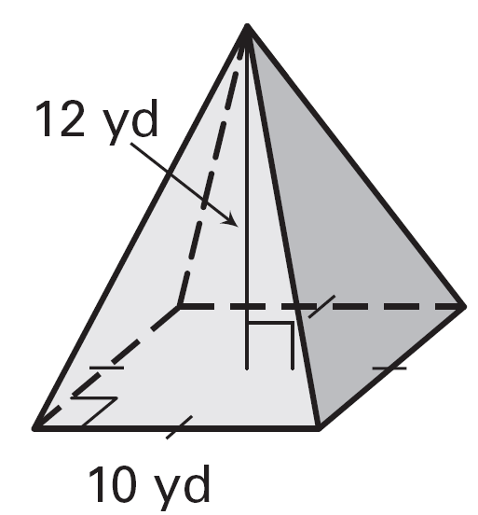

V = _____________

6. Find the volume of the cone.
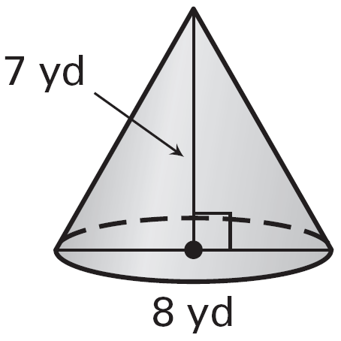

V = _____________

7. Find the volume of the cone.
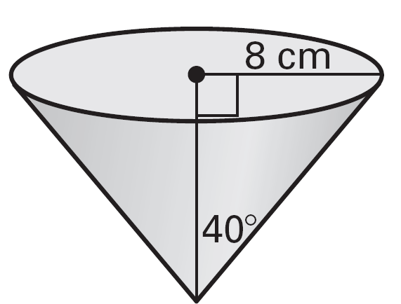

V = _____________

8. Find the volume of the solid.
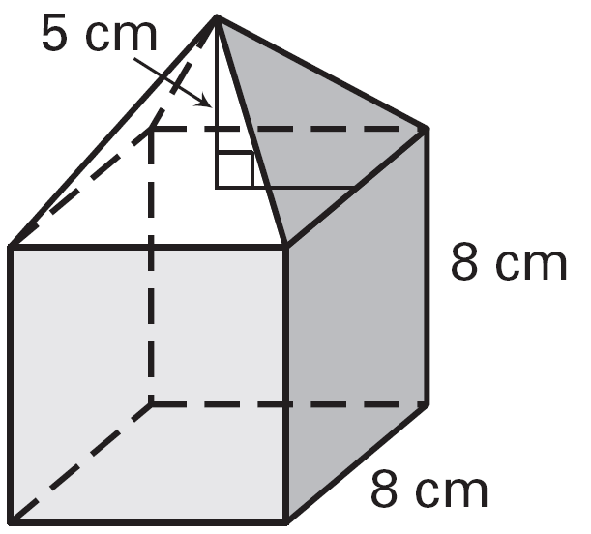

V = _____________

9. Find the volume of the solid.
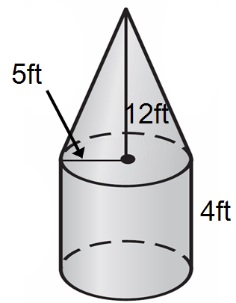

V = _____________

